### Spinner Ornaments

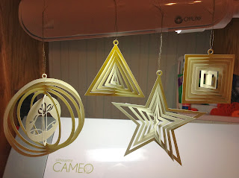

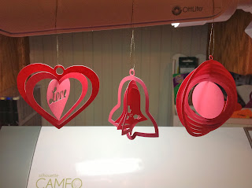

Spinner ornaments are shapes which are offset numerous times using the Silhouette designer software. Each offset is held onto the next with a small sliver of paper. These ornaments are a little delicate so do not spin the paper too many times or else you will tear the paper. I have seen these ornaments as mobiles that can be hung outdoors. In fact, if you cut it on a plastic material such as a transparency, you can hang them up outdoors.  
  
These spinners can also be used as gift tags for a present.



